**TABLES**

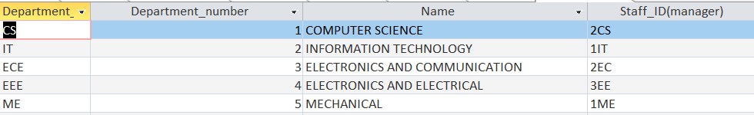DEPARTMENT

This table holds data related to all the Departments of the college. Every department tuple has a unique **Department number** which acts as the primary key of the table.

The department is managed by a staff member whose details are referenced through the staff id attribute (foreign key).

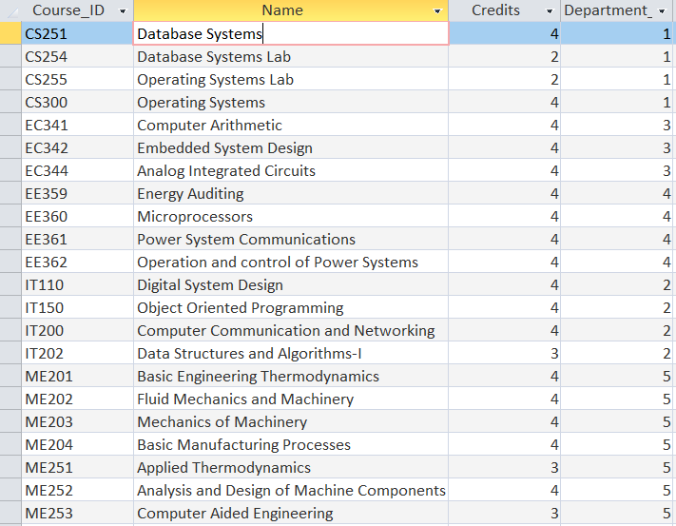COURSES TABLE

This table stores information regarding each course that the above-mentioned departments provide. Each course has a unique **Course ID** which is the primary key of this table.

STUDENT:

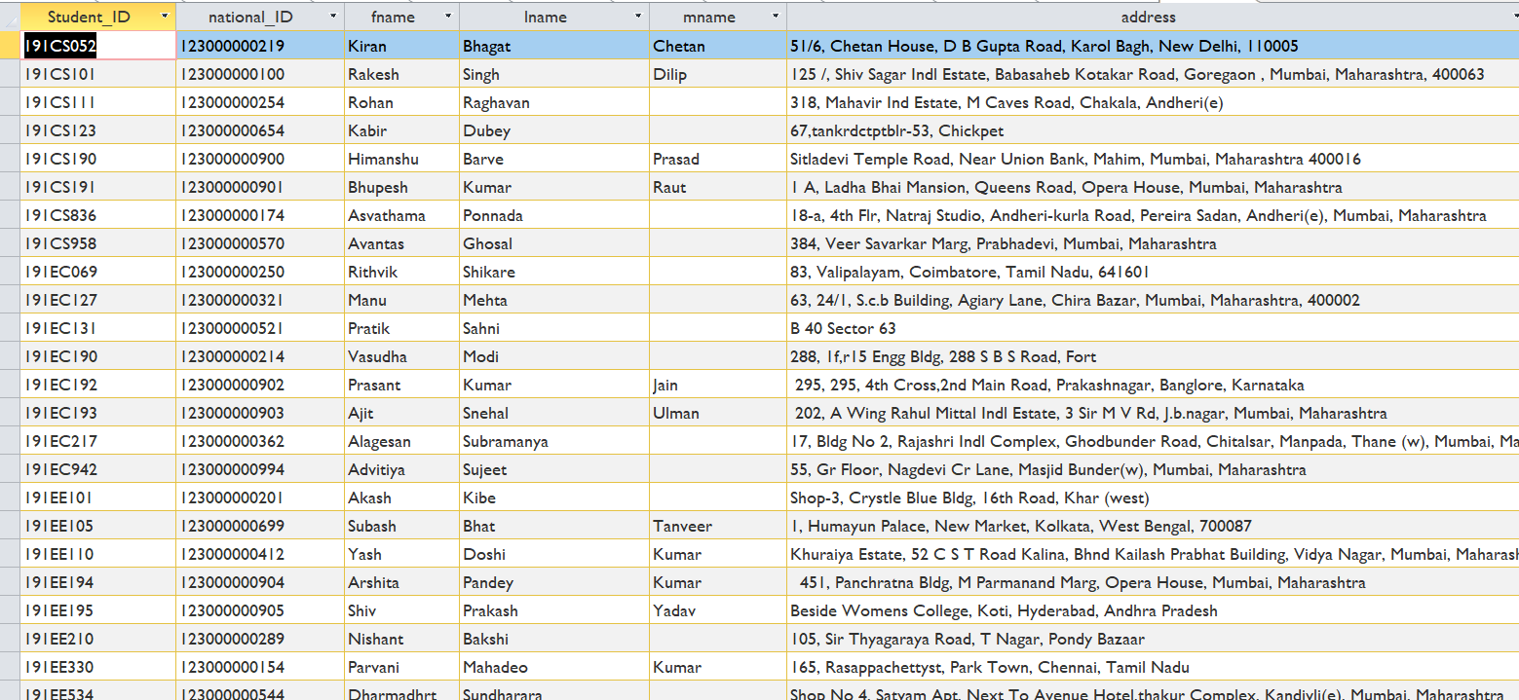Details of all the registered students are stored in the Student table. **Student id** is the primary key of the table. Apart from student id, national id is also unique for different tuples of the table.

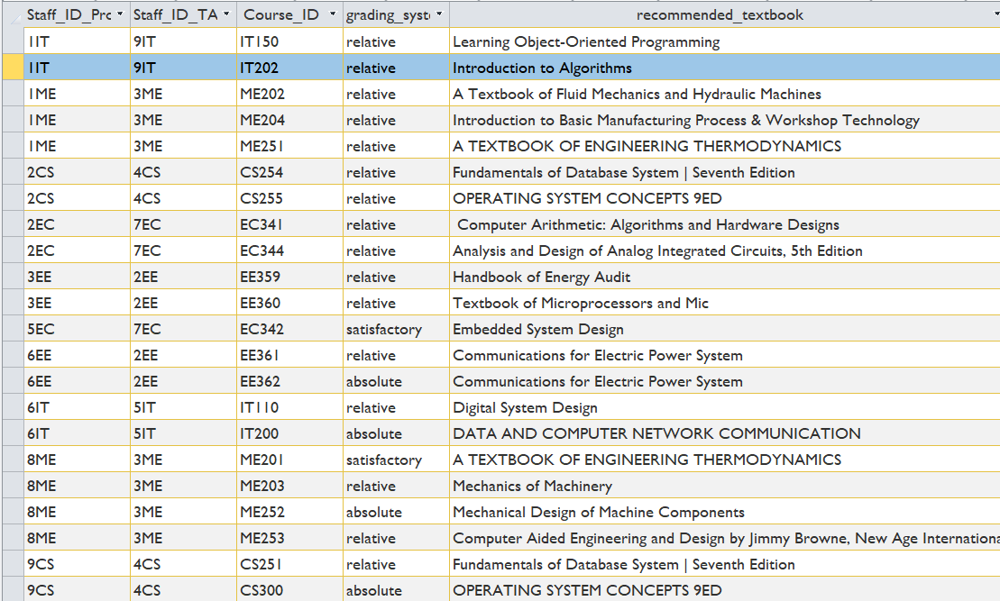TEACHING:

This table gives details of how a course is taught by defining the professor in charge of the course, the teaching assistant and the course id of the course. Other attributes provide more details of the course. The primary key of this table is the **combination of the professor staff id, teaching assistant staff id and the course id.**

ENROLLMENT:

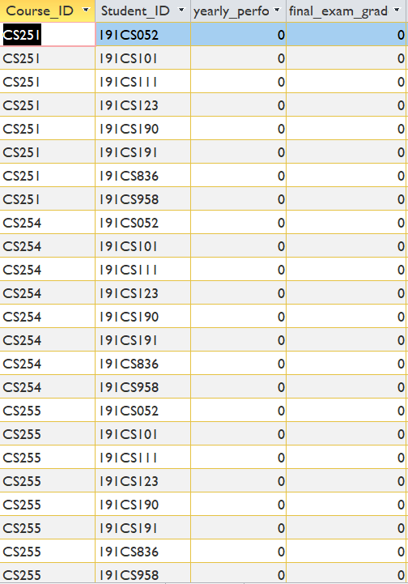This table keeps track of the courses that a student has registered for. The student id and the course id are used for this purpose. The primary key is the **combination of Course Id and the student ID.**

STAFF MEMBERS:

Details of all the staff members who are either Professors or Teaching assistants are stored in this table with each entry having a unique **Staff id** which is the primary key of the table.

When the ISA relation between Staff members, TA and professor is converted to the relational model, the latter two tables still have the same attributes as staff member but need to distinguished from each other due to the roles they have in the remaining tables.

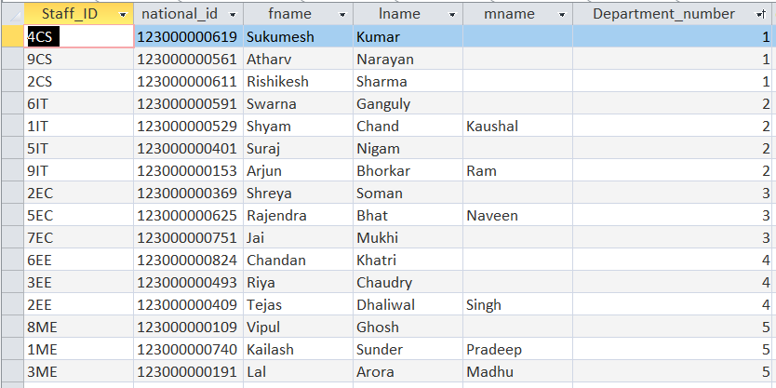Hence the tables, Professor and Teaching assistant, have only one attribute which is the foreign key that references the staff member table for complete details of each of them.

PROFESSOR: TEACHING ASSISTANT:

